|  |
| --- |
| Pooh’ world  **[pooh logo](http://www.pooh.it/)** |
| Pooh’s Adventure |
| **Getting coins** |
| Version #01  All work Copyright © 2016 by Pooh’s world  All rights reserved. |
| **[Jiho Yoo]** |
|  |

|  |
| --- |
| Feb 29th 2016 |

**Table of Contents**

Version History 3

1. Game Overview 3

2. Game Play Mechanics 3

*3.* Camera 3

4. Controls 3

5. Interface Sketch 4

6. Menu and Screen Descriptions 4

7. Game World 5

8. Levels 5

9. Characters 6

10. Enemies 6

11. Abilities 6

12. Script 6

13. Scoring 6

14. Sound Index 6

15. Art/ Multimedia Index 7

# Version History

* Feb 20, 2016 - set background and images.

* Feb 22, 2016 - write codes

* Feb 26, 2016 - set audios

* Feb 29, 2016 - found errors

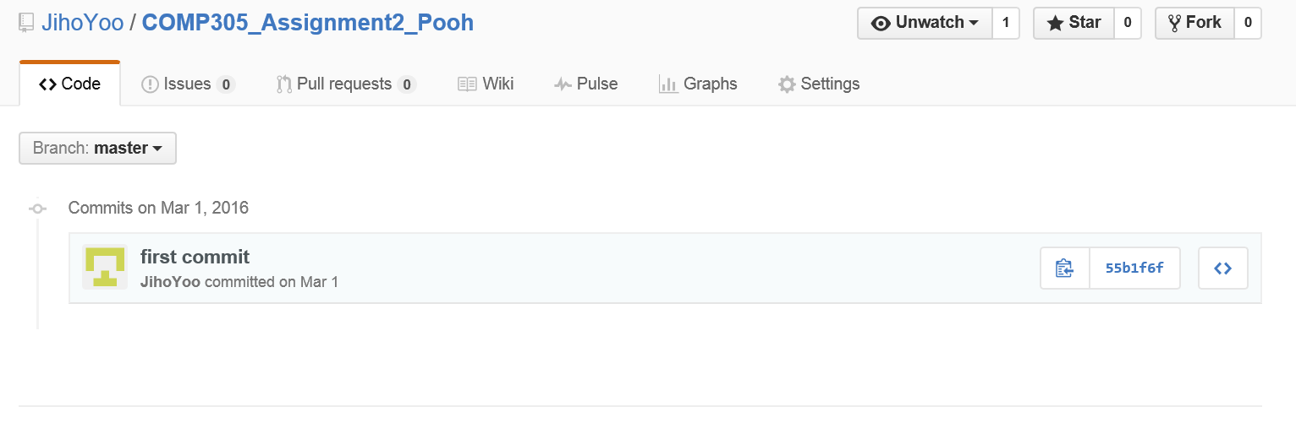

## Game Overview / Game Description

The game is that the hero gets coins and the hero avoids enemies by controlling.

When the hero’s life values are zero, the restart button shows up for user. So, if the user wants restart the game, the user can press the button.

## Game Play Mechanics

Avoid enemies, and get coins!!

## Camera

2D

## Controls

-Use Key bored

## Interface Sketch

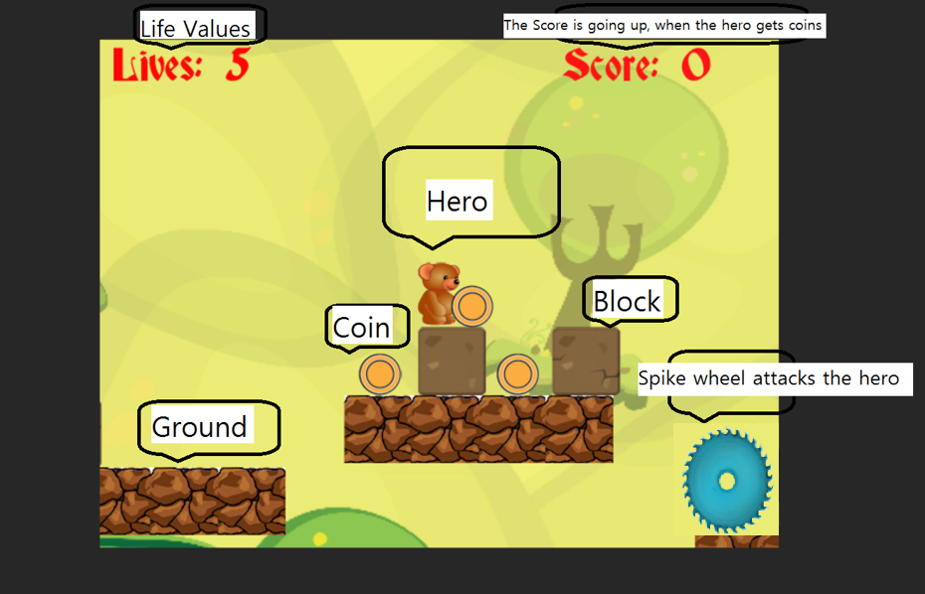

## Menu and Screen Descriptions

1. Start Game

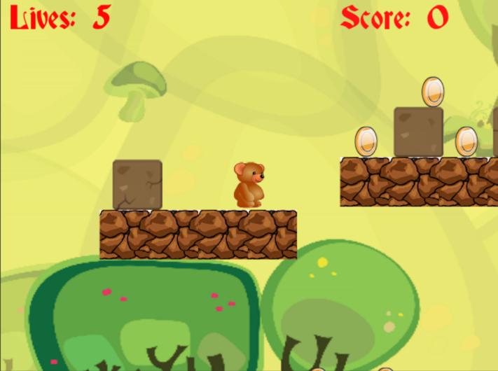

1. *Play Game*

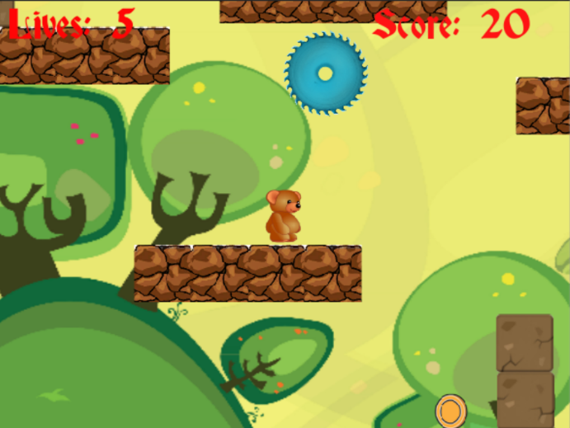

1. *End Game*

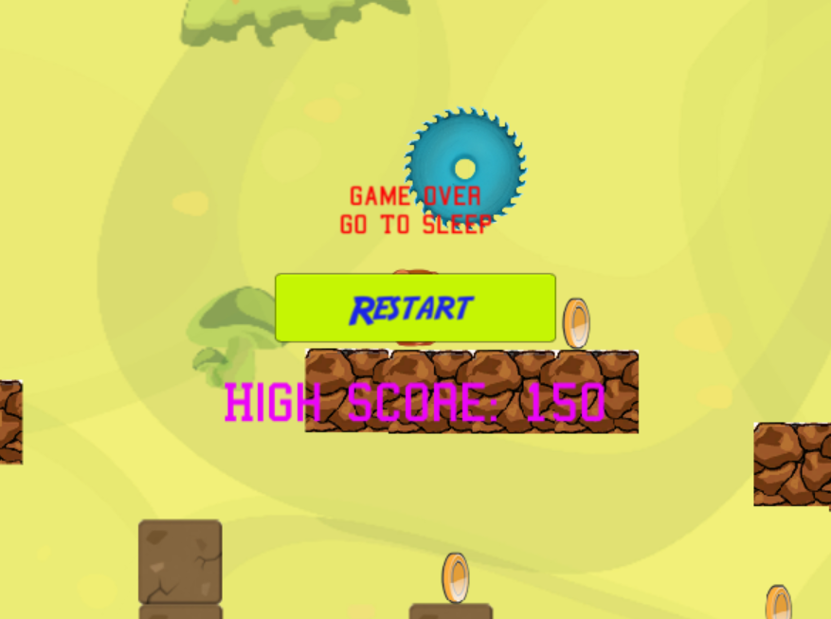

## Game World

**-White forest world because the forest was destroyed.**

## Levels

* Easy

## Characters

* Cute Pooh: This is Hero. The hero can jump and can get coins.

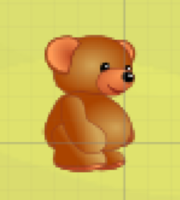

## Enemies

* The spike is set up frequently.



## Abilities

-The Pooh has 5 lives when you start game

## Script

* GameController
* HeroController
* SpikedWheelController

## Scoring

* If you get coins the scores are going up

## Sound Index

* hero_pickup : when you get coins
* hero_jump: when the Pooh jump
* hero_hurt: when the Pooh crushed spike or drop from ground
* Background : game music

## Art/ Multimedia Index

* Spike(enemies)

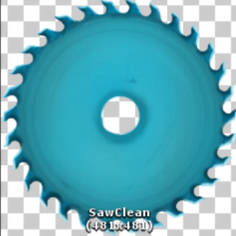

* coin (coins)

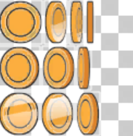

* hero(pooh)

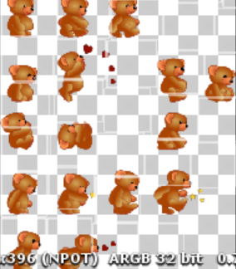

* ground(ground)

